Core Java is used to write the core/business logic of any Java application, regardless of the application type.
The application can be of any type like
• Desktop applications
• Web applications
• Android applications

For different types of applications, the UI (User Interface) technologies are different.
Application Type | UI Technologies
Desktop Applications | Swing, JavaFX
Web Applications | HTML, CSS, JavaScript
Android Applications | Android XML layouts, Android UI components

However, the business logic of the application is written using Core Java concepts such as classes, objects, collections, exception handling, file handling, etc.

1️⃣ Class
A class is a blueprint used to create objects.
It defines the variables and methods that an object will have.
Example:
class Student {
int id;
String name;
}

2. Package
After compilation, Java source files become .class files.
A package is a group of related classes and interfaces (their .class files).
Example:
java.sql
│
├── Connection.class
├── Statement.class
├── ResultSet.class
└── DriverManager.class
So:
Package = collection of classes and interfaces (.class files)

3. Library (JAR)
A library is a JAR file that packages multiple packages together.
Example:
mysql-connector-j.jar
│
├── com/mysql/cj/jdbc
│ ├── ConnectionImpl.class
│ ├── StatementImpl.class
│ └── ResultSetImpl.class
│
├── com/mysql/cj/protocol
│ └── protocol classes
│
└── com/mysql/cj/util
└── utility classes
So:
Library (JAR)
↓
contains multiple packages
↓
packages contain classes/interfaces

4. Final Hierarchy
Methods
↓
Class / Interface (.class)
↓
Package
↓
Library (JAR file)

1️⃣ Definition of API (Again)
API means:
A set of rules that tell programmers how to use some functionality.
Those rules tell you:
- which classes or interfaces to use
- which methods to call
- what input to give
- what output you will receive

2️⃣ What Functionality Does JDBC Provide?
JDBC provides the functionality:
Java program ↔ Database communication
So JDBC tells developers how Java programs should interact with databases.
Example tasks:
- connect to database
- execute SQL query
- get results from database

3️⃣ How JDBC Defines the Rules
JDBC API defines rules using interfaces and methods.
Example rule 1:
To connect to a database → use Connection
Example rule 2:
To execute SQL → use Statement or PreparedStatement
Example rule 3:
To read results → use ResultSet
So JDBC tells developers:
Use these interfaces
Use these methods
Follow this flow

4️⃣ Example of JDBC API Rules
The JDBC API defines interfaces like:
Connection
Statement
PreparedStatement
ResultSet
Inside them, it defines methods.
Example:
Connection interface rule:
createStatement()
prepareStatement()
close()
Statement interface rule:
executeQuery()
executeUpdate()
ResultSet interface rule:
next()
getInt()
getString()
These are rules defined by the JDBC API.

5️⃣ Example JDBC Program
Connection con = DriverManager.getConnection(url);
Statement st = con.createStatement();
ResultSet rs = st.executeQuery("select * from student");
Here the API tells you:
Call getConnection()
Call createStatement()
Call executeQuery()
Use ResultSet to read data
That is exactly the rules of the API.

6️⃣ Who Implements These Rules?
Database driver libraries implement them.
Examples:
- MySQL driver
- Oracle driver
- PostgreSQL driver
Example implementation:
ConnectionImpl implements Connection
So:
JDBC API → rules
Driver library → implementation of rules

7️⃣ Final Connection Between API Definition and JDBC
Now linking your definition:
API = rules that tell developers how to use functionality
For JDBC:
Functionality → Database communication
Rules → Use Connection, Statement, ResultSet, etc.
So JDBC API tells developers:
How to connect to database
How to execute SQL
How to retrieve results

8️⃣ One Simple Sentence
You can explain JDBC API like this:
JDBC API is a set of rules defined using interfaces and methods that tells Java developers how to connect to a database, execute SQL queries, and retrieve results.

Technology
Technology
A technology is a complete solution used to solve a particular problem in software development.
It usually includes:
- APIs (rules to use the technology)
- Libraries (implementation code)

Technology says: "I provide the solution for this problem."
API says: "These are the rules developers must follow to use that solution."

Examples of Java Technologies
JDBC → database communication
It is called a technology because it provides APIs, rules, and architecture that define how Java programs connect to databases and execute SQL queries.
Servlet → handling web requests
It is called a technology because it provides APIs and rules that define how Java programs process HTTP requests and send responses in web applications.
JSP → creating dynamic web pages
It is called a technology because it provides APIs and architecture that define how dynamic web pages can be generated using Java.

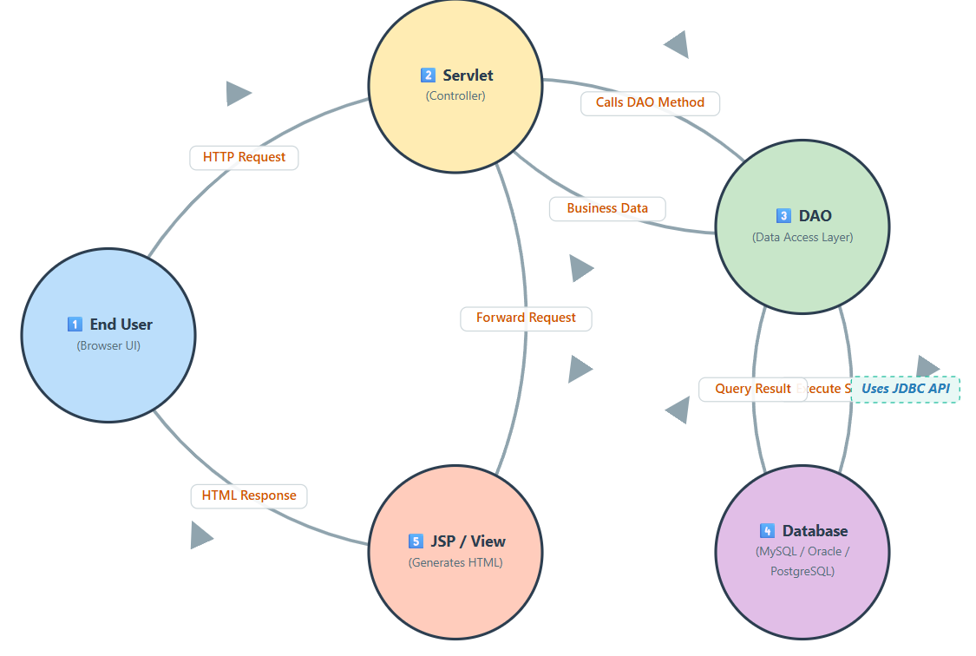

⭐ Correct Web Application Flow (Servlet–JSP Architecture)
1️⃣ End User → Front-End (UI)
The user interacts with the UI through a browser.
The UI can be created using:
• HTML
• CSS
• JavaScript
• Forms
• Or modern frameworks like React / Angular
The browser sends an HTTP request to the server when the user submits a form or clicks a button.
Example:
<form action="/process" method="post">
The request is sent to the server URL mapped to a Servlet.

2️⃣ Front-End Request → Servlet (Controller)
The Servlet acts as the controller.
It receives the HTTP request and extracts the data sent by the user.
Example:
String name = request.getParameter("name");
String dob = request.getParameter("dob");
The servlet is responsible for:
• receiving request data
• validating input
• coordinating business logic

3️⃣ Servlet → DAO (Data Access Layer)
In well-structured applications, the Servlet should not directly access the database.
Instead it calls a DAO (Data Access Object).
Example:
AstrologyDao dao = new AstrologyDao();
String result = dao.getAstrology(name, dob);
DAO is responsible only for database operations.
DAO contains:
• JDBC code
• SQL queries
• database connections
• result processing

4️⃣ DAO → Database (Using JDBC)
The DAO communicates with the database using JDBC.
Typical steps:
• establish database connection
• execute SQL query
• retrieve result from database
• return result to the servlet
Flow:
DAO → JDBC → Database

5️⃣ Servlet → JSP / Thymeleaf (View Layer)
After receiving the result from DAO, the Servlet forwards the data to the view layer.
Example:
request.setAttribute("result", result);
request.getRequestDispatcher("result.jsp").forward(request, response);
The JSP or Thymeleaf page generates the final HTML response.
Important points:
• JSP runs on the server
• It generates HTML
• The browser only receives HTML output
So the user actually sees HTML, not JSP code.

⭐ Correct Final Flow
User (Browser)
↓
HTML / React / Angular UI
↓
Servlet (Controller)
↓
DAO (Data Access Layer)
↓
JDBC
↓
Database
↓
DAO
↓
Servlet
↓
JSP / Thymeleaf (View generates HTML)
↓
HTML Response
↓
User (Browser)

⭐ Responsibilities of Each Component
✔ Servlet → request handling + application logic coordination
✔ DAO → database communication
✔ JDBC → database connectivity technology
✔ JSP / Thymeleaf → view layer (generates HTML)
✔ Browser → displays the HTML to the user

